Azure Virtual Networks and Virtual Machines

1. Create an ARM Template for a virtual network with subnets and Network Security Group with Inbound Outbound rules.

Step 1: Go to Azure portal <https://portal.azure.com>. Click on create a new resource and select template deployment in the marketplace.

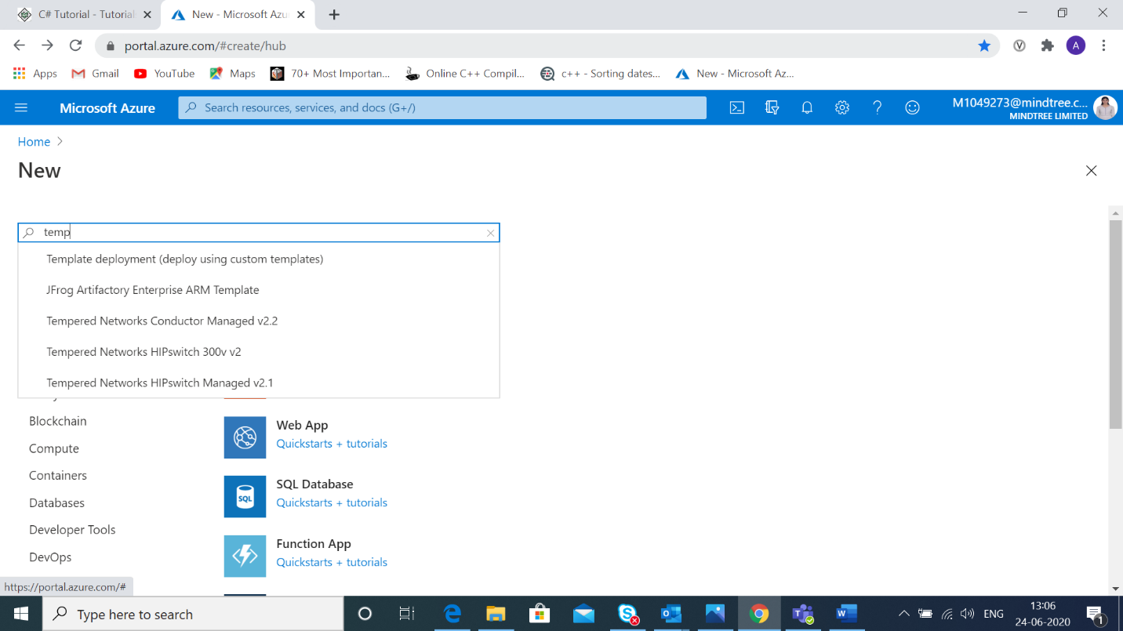

Step 2: Click on build your own template.

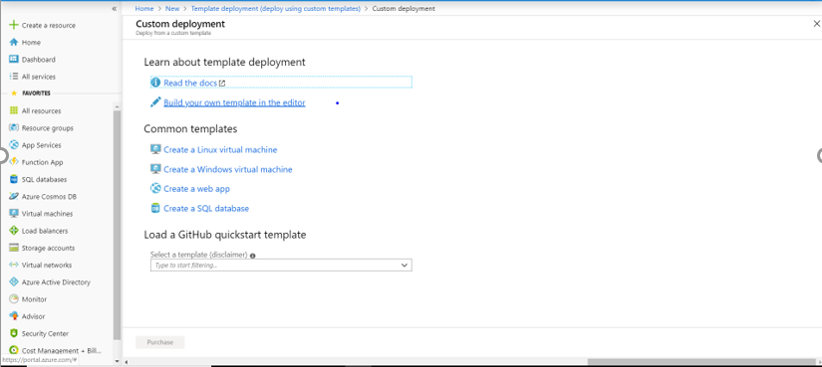

Step 3: Write the ARM template for creating a network group with inbound and outbound rules as shown.

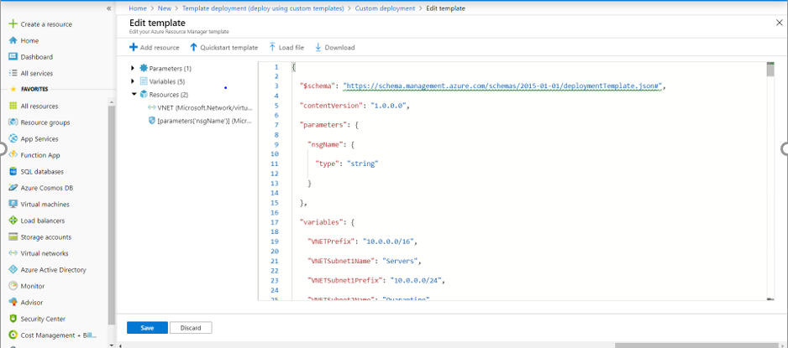

Step 4: Save and purchase the template. We will get a notification that the deployment is in progress. Now, under “all resources” we can see our network group.

